Linda Li-chuan Chiang, Ph.D
Curriculum Vitae

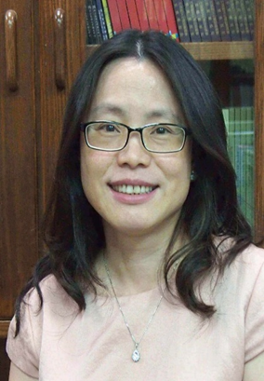

Current Position
Professor & General Secretariat (August, 2012~)
Department of Education
National University of Tainan (NUTN), Tainan, Taiwan.

Contact Information
Address: No. 33, Section 2, Su-Lin Street, Tainan City, Taiwan
Tel: +886 6 2133111 ext. 110
Fax: +886 6 2141443
E-mail: lcchiang@mail.nutn.edu.tw

Educational Background
MA of National Kaohsiung Normal University, Taiwan (1991~1993)
PhD of Institute of Education, University College London (UCL), U.K. (1995~2000)
Major: Comparative Higher Education
Thesis titled ‘The Relationship between University Autonomy and Funding in England and in Taiwan’

Previous Work Experience
Junior high school teacher (1989~1991)
Mid-rank officer in the Kaohsiung city government (1993~1995)
Assistant professor of National University Chi-Nan University (2000~2002)
Assistant professor of National University of Tainan (2002~2004)
Associate professor of National University of Tainan (2004~2011)
Head of Institute of Educational Management and Entrepreneurialship, NUTN (2009~2011)

Research Interests
globalization and higher education, internationalization of higher education, transnational higher education (TNHE), and academic profession

